**Array function =>**

Array function is an **anonymous** function with some modifications. These modifications are:

1. Omit function keyword.
2. Put **=>** between the ) {
3. If your function has only one parameter in this case you can delete **parenthesis** () of this parameter.
4. If your function has only return statement then you can delete it and also delete { } of the function body.

**Example 1:** on Array function with => part and without function keyword.

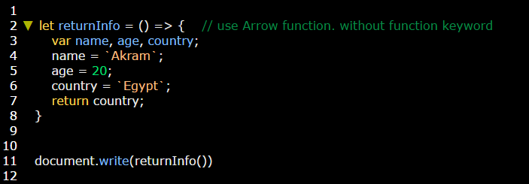

**Example 2:** on Array function with one parameter (**x**) and without return statement & { } of function body.

